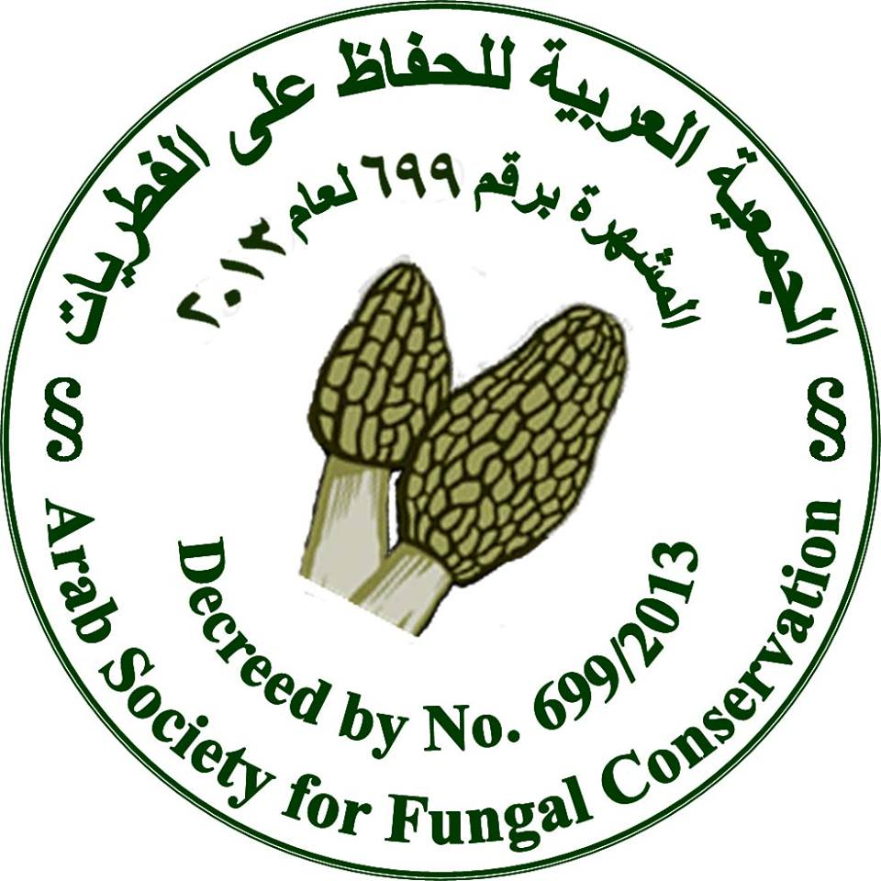
I’m Supporting the

Arab Society for Fungal Conservation


To Declare

20th February 2016

The Bibliotheca Alexandrina
The Auditoruim Hall, BA Main Building, 3:00 PM

http://www.fungiofegypt.com/20Feb/

NAME:

LOCATION:


